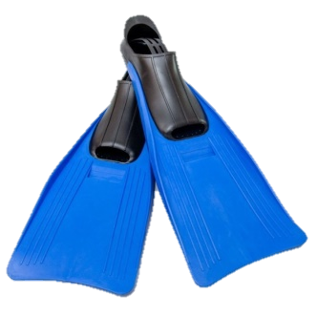 | FLIPPERS | LILO | 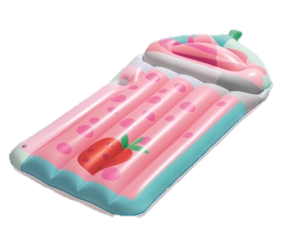
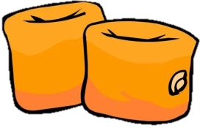 | ARMBANDS |  | SUN HAT
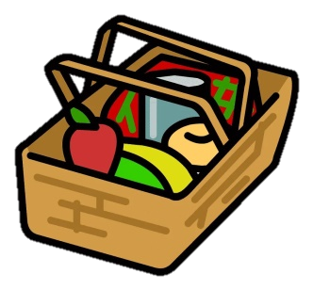 | PICNIC BASKET | 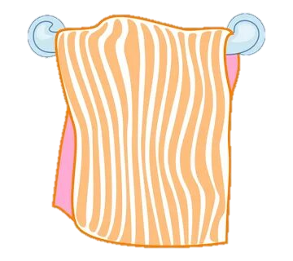 | TOWEL

 | FLIPPERS | LILO
 | ARMBANDS |  | SUN HAT
 | PICNIC BASKET |  | TOWEL

 | FLIPPERS | LILO
 | ARMBANDS |  | SUN HAT
 | PICNIC BASKET |  | TOWEL

 | FLIPPERS | LILO
 | ARMBANDS |  | SUN HAT
 | PICNIC BASKET |  | TOWEL

